History of Mass Shootings in the United States

By: Kaden Fuller-Aujla

**Table of Contents**

Introduction………………………………………………………………………………………..3

Characterizing a Set of Measurements: Graphical Methods………………………………………4

Characterizing a Set of Measurements: Numerical Methods……………………………………..4

A Review of Set Notation…………………………………………………………………………5

A Probabilistic Model for an Experiment: The Discrete Case……………………………………6

Calculating the Probability of an Event: The Sample-Point Method……………………………..7

Tools for Counting Sample Points………………………………………………………………...8

Conditional Probability and the Independence of Events…………………………………………8

Two Laws of Probability…………………………………………………………………………..9

Calculating the Probability of an Event: The Event Composition Method……………………….9

The Law of Total Probability and Bayes’ Rule……………………………………………………9

The Probability Distribution for a Discrete Random Variable…………………………………...10

The Binomial Probability Distribution…………………………………………………………..10

The Geometric Probability Distribution…………………………………………………………11

The Hypergeometric Probability Distribution…………………………………………………...11

Poisson Probability Distribution…………………………………………………………………12

Tchebysheff’s Theorem………………………………………………………………………….12

Conclusion……………………………………………………………………………………….13

## Introduction

Mass shooting are becoming more and more prevalent as the years move forward with most of them being even in the last 10-15 years, even though they have occurred before this. There is an increasing probability that this can happen to someone you know and love. While they may seem random at the time of occurrence, taking a deeper dive there is usually much more to the story that we seem to miss on surface level. People who have illegal weapons, mental issues, or signaling in advance they will do this. There are so many moving variables in situations like this it is almost impossible to track, but we collect as many points as we can of data.

Not only is some of this data somewhat important in characterizing certain types of people as more likely to be a shooter, but maybe can paint a fuller picture on other statistics on these tragic events. I truly believe we should be looking more into datasets like this to be able to get some better answers. I do not believe it is fair to victims, their families, and friends that most of the time there is no answer to why these were not seen before or why it happens to them. All we can try and do is continuously learn from these points of data and make changes. If we keep gathering data with no change or even analysis of it, why gather the data…? We must learn from it.

With all, I also believe we should be collecting more information and storing it in public databases just like how we do with other criminals and making it more available and out in the public. It is a real fear, but it should not be.

## **1.2** Characterizing a Set of Measurements: Graphical Methods

Exercises

**1.2** Is a certain gender more likely to commit a mass shooting? Please refer to the excel file linked for all the data.

**A** Construct a relative frequency histogram for these data points. Male will be 0, and Female will be 1.

***Figure 1.2***

**B** Do you think it is strange that 95% of the mass shootings in the US happen by males?

Personally, I think it is very strange, when there is that large of a % in one direction it makes it seem like there must be more factors involved in this.

## **1.3** Characterizing a Set of Measurements: Numerical Methods

Exercises

**1.9** The fatality rate among mass shootings is approximately normally distributed with mean 7.78 and standard deviation 7.44. What fraction of people are in the following ranges?

**A** 6 to 12 fatalities

**Solution** Approximately 68%

***Figure 1.3***

## **2.3** A Review of Set Notation

Exercises

**2.2** Suppose that A and B are two events. Write expressions involving unions, intersections, and complements that describe the following:

**A** Both events occur.

$$A∩B$$

**B** At least one occurs.

$$A∪B$$

**C**  Neither occurs.

$$A'∩B'$$

**D** Exactly one occurs.

$$(A∩B^{'})∪(A'∩B)$$

***Figure 2.3***

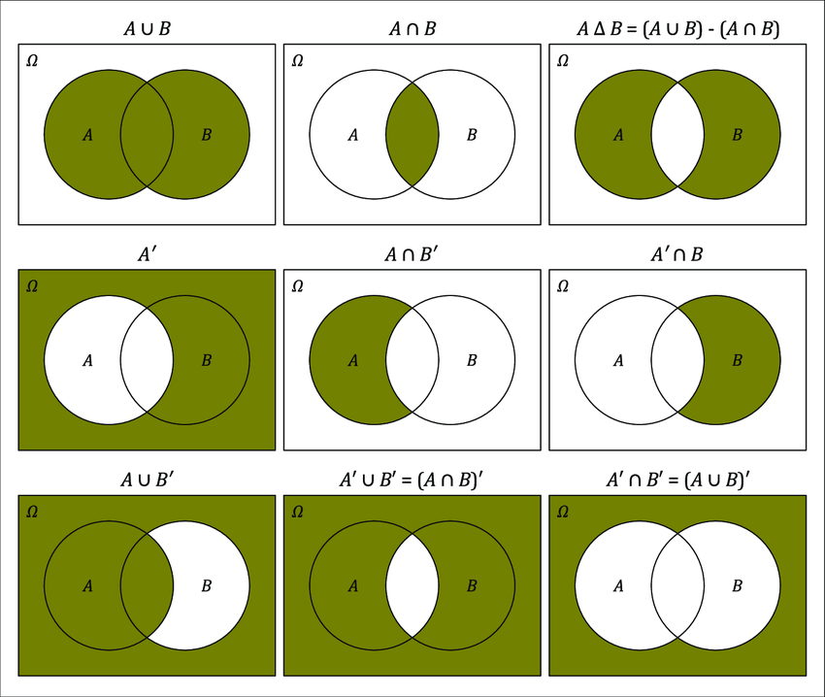

## **2.4** A Probabilistic Model for an Experiment: The Discrete Case

Exercises

**2.1** A person has five seemingly identical men in front of her. Unknown to her two of the five have mental illness. Two of them are randomly selected out of the five available.

**A** List the sample space for the experiment.

**Solution** Let the two mentally ill men be labeled as U1 and U2, and the three mentally healthy men be labeled as H1, H2, and H3.

E1 = {U1, U2} E2 = {U1, H1} E3 = {U1, H2} E4 = {U1, H3}

E5 = {U2, H1} E6 = {U2, H2} E7 = {U2, H3} E8 = {H1, H2}

E9 = {H1, H3} E10 = {H2, H3}

**B** Let A denote the event that two men are chosen who are healthy.

**Solution** Event A = {E8 ,E9 ,E10}

**C** Construct a Venn diagram for the experiment

**D** Assign probabilities to the events

**Solution** P(E1)=1/10 for i = 1-10

**E** Find the probability of event A

**Solution** P(A)=P(E8)+P(E9)+P(E10) = 3/10

## **2.5** Calculating the Probability of an Event:

## The Sample-Point Method

Exercises

**2.25** A single shooter is randomly selected from among all of those reported in the data. What do you think of the following claim? “All shooters are either male, or they are not. Therefore, the probability is ½ that the person selected is a male.”

**Solution** This is an accurate claim because in the problem it uses the word either which indicates it must be one or the other. So, if all shooters are either male or not, there are two options making it either male, or other.

\**Since we already calculated the probability of an event using the sample point method in the previous chapter, I chose a different question\**

## **2.6** Tools for Counting Sample Points

Exercises

EXAMPLE **2.5** An experiment involves tossing a coin and observing the outcome on the top face. Find the number of sample points in S, the sample space for the experiment. Heads represent male and tails represent female.

**Solution** M = N = 2, the total number of sample points in S is MN = (2)(2) = 4

EXAMPLE **2.11** Find the number of weapon combinations that can be used out of 4 weapon choices (AR, SR, Shotgun, Handgun) if the shooter uses 2 weapons (most shooters used more than one weapon).

**Solution $\left({4 \atop 2}\right)$**  = 6 combinations of weapons

EXAMPLE **2.8** Find the number of weapon permutations that can be used out of 4 weapons (often shooters run out of ammunition and switch to a different weapon) if the shooter can only use 2 firearms.

**Solution $P_{2}^{4}$**  = 12 permutations of weapons

## **2.7** Conditional Probability and the Independence of Events

Exercises

**2.71** What is the probability the weapon was obtained legally, given that each shooting some sort of firearm was recovered.

**Solution** A: Weapon was obtained legally.

B: There was a firearm present.

Using definition 2.9 (A|B) $=\frac{P(A∩B)}{P(B)}$ = $\frac{.68}{1}=.68$

There was a 68% chance it was obtained legally given there was a firearm present.

## **2.8** Two Laws of Probability

**Proof $P\left(A∩B\right)=P\left(A\right)P\left(B | A\right)=P\left(B\right)P(A|B)$**

Exercises

**2.88** Suppose that A and B are two events such that P(A) = .5 and P(B) = .2.

**A** Is it possible that $P\left(A∩B\right)= .1?$ Why or why not?

**Solution** Yes, it is possible since it can be any value from 0 to .2 because this is the intersection.

## **2.9** Calculating the Probability of an Event: The Event-Composition Method

Exercises

EXAMPLE **2.17** Of the shooters, 47% had a mental issue and 53% did not or it was unclear, Among the mentally ill, 63% were white, whereas 37% without a mental issue were white. If one of them is selected at random, what is the probability they will be white?

**Solution** = (.47)(.63) = .29

= (.53)(.37) = .19

P(F) = .29 + .19 = .48

Therefore, there is a 48% chance the shooter will be white if selected at random, which is considerably high given the fact there are 6 races on the list including White, Black, Asian, Latino, Native American, and Other

## **2.10** The Law of Total Probability and Bayes’ Rule

Exercises

**2.23**

## **3.2** The Probability Distribution for a Discrete Random Variable

Exercises

EXAMPLE **3.1** A shooter is going to choose two victims at random out of a group of three teachers and 3 students. He is going to select these people at random, because he does not care who the victims are, he just wants to maximize his time. Let Y denote the number of teachers in his selection. Find the probability distribution for Y.

**Solution**

$$p\left(0\right)=P\left(Y=0\right)=\frac{\left({3 \atop 0}\right)\left({3 \atop 2}\right)}{15}=\frac{3}{15}=\frac{1}{5}$$

This will be the same for p(2) because the numbers will just be flipped from top right to left.

$$p\left(1\right)=P\left(Y=0\right)=\frac{\left({3 \atop 1}\right)\left({3 \atop 1}\right)}{15}=\frac{9}{15}=\frac{3}{5}$$

This makes sense and is the most likely occurrence since the number of teachers and students are equal.

## **3.4** The Binomial Probability Distribution

Exercises

**3.7** Suppose a group of mass shooters contains 200 people and it contains 5% African American people. If a sample of 5 people are taken, find the probability of one of them being African American.

**Solution**

$$P\left(at least one African American\right)=1-P\left(0\right)=1-\left({5 \atop 0}\right)p^{0}q^{5}$$

$$=1-{\left(.95\right)}^{5}=1-.744=.226$$

There is around a 22% chance that one of them will be African American, and the actual % is 17.6% in the dataset.

## **3.5** The Geometric Probability Distribution

Exercises

**3.111** Suppose the probability of a mass shooting during 52-week period is p = .02. Find the probability that a shooting will not happen for 2 years.

**Solution**

$$P=\left(last 2 years\right)=P\left(Y≥3\right)=\sum_{y=3}^{∞}{p\left(y\right)}$$

$$\sum_{y=1}^{∞}{p\left(y\right)=1}$$

$$P\left(survive two hours\right)=1-\sum_{y=1}^{2}{p\left(y\right)}$$

$$=1-p-qp=1-.02-\left(.98\right)\left(.02\right)=.9604$$

Therefore, there is a 96% chance a mass shooting would not happen in 2 years which is good, but considering how easy it is to have someone related to you or someone you know in the 4% it is still scary thought. If you have parents, siblings, and kids you are at a very high risk.

## **3.7** The Hypergeometric Probability Distribution

Exercises

**3.177** From a group of 40 mass shooters, 20 are randomly selected. What is the probability that the 15 selected include the 10 most ruthless shooters in the group of 40.

**Solution**

N = 40, n = 20, and r = 10, Y = 10

$$p\left(10\right)=\frac{\left({10 \atop 10}\right)\left({30 \atop 10}\right)}{\left({40 \atop 20}\right)}=.0002$$

## **3.8** Poisson Probability Distribution

Exercises

**3.222** Mass shooters randomly appear across the country, with a density of 3 per state. If someone goes to a random state what is the probability, they will encounter a mass shooter?

**Solution**

$$P\left(Y=0\right)=p\left(0\right)=\frac{λ^{0}e^{-λ}}{0!}=e^{-3}=0.49$$

There is roughly a 5% chance you will cross paths with an existing or future mass shooter if you visit a random state which is a 1/20 chance if you are constantly visiting states it is bound to happen. Which is scary.

## **3.11** Tchebysheff’s Theorem

Exercises

**3.281** The number of fatalities over time during mass shootings, Y, has been observed and determined to have a mean of 7.78 and standard deviation 7.44 (found in section 1.3). The probability distribution of Y is not known, what can be said about the probability that, the next mass shooting fatality number Y will be greater than .34 but less than 15.22?

**Solution**

$$μ=7.78 and σ=7.44, it follows that μ-kσ= .34 and μ+kσ=15.22 if k=7.44$$

Thus,

$$P\left(.34<Y<15.22\right)=P\left(μ-1σ<Y<μ+1σ\right)≥1-\frac{1}{{7.44}^{2}}=\frac{54.3}{55.3}=98.1\%$$

This is an extremely high probability and in fact lines perfectly with the data while a vast majority of these fatalities lie between these 2 numbers with random outliers reaching 40-50 on rare occasions. Sometimes these include the person who is the shooter as they take their own lives.

\*\**I did not believe that the theorems and definitions in section 4 could fit my dataset as most of them had a need for continuous variables which my set did not have. Additionally, the other half of the chapter does not apply since we did not go over it or skipped the beta/gamma. \*\**

## Conclusion

I know this was a lot of information to take in, but it was only a fraction of the entirety of what is collected. In the sheet attached I have the set and some of my charts and calculations I did along the way. Some of the data cannot be properly put into these formulas whether it is because it is not continuous, or it does not fit a good example problem. I attempted to fit the data as much as possible and make it a good learning experience for people to read about.

Overall, I believe mass shootings should be explored more on what the root cause is. Although it is a very complicated subject and is filled with variables there are some key things we can focus on. Such as the topics of guns, and mental health. These are two things we cannot be overlooking and seem to always be some sort of issue when there is a mass shooting. Either a weapon is obtained illegally, or someone is mentally ill in the situation.

We must do better as a society, things need to start changing even if it is minimal at first, hopefully it can grow into a snowball or exponential affect on people. There is no point in needless deaths.